**Check if Ryland Homes or Ryland Group Inc exists in the Compustat dataset**

Dataset: ciqcompany_mergedwithgvkeyandcountry.csv

Pre-processing: converted firm names to lower case. No other pre-processing done.

Results for Ryland Homes

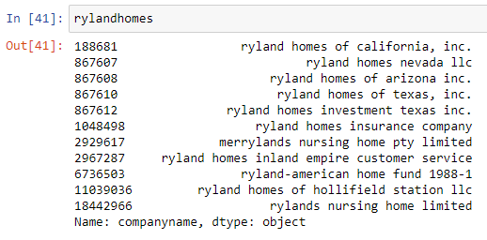

Results for Ryland Group Inc

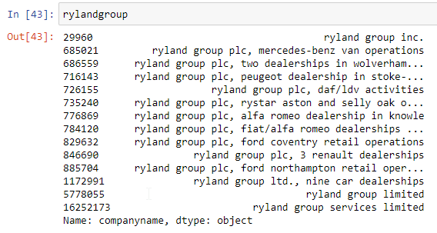

**Best Match: Ryland Group Inc (Index: 29960)**

